H.T No
Regulations:
A15


Sreenidhi Institute of Science and Technology
(An Autonomous Institution)
Code No: 5AC41 Date: 15-June-2019 (AN)

B.Tech II Year I-Semester External Examination, June-2019 (Supplementary)
Elements of Electrical Engineering (CSE and IT)

Time: 3 Hours Max.Marks:75

Note: a) No additional answer sheets will be provided.
b) All sub-parts of a question must be answered at one place only, otherwise it will not be valued.
c) Missing data can be assumed suitably.

Part - A Max.Marks:25

Answer all QUESTIONS.

1. | Give the statement of Superposition theorem. | [3M]
2. | Define R.M.S. value of an alternating quantity and its value for cosine wave? | [3M]
3. | Give the function of back emf in a DC motor? | [3M]
4. | Draw the vector diagram of transformer for lagging p.f. load. | [3M]
5. | A 6-pole, 3-Ph induction motor is fed from 50Hz supply. If the frequency of rotor at full load is 2Hz, Find full load speed. | [3M]
6. | Mention the applications of PMMC instrument. | [2M]
7. | List-out the advantages of AC over DC. | [2M]
8. | Write the condition for the maximum efficiency of a transformer? | [2M]
9. | Give the relation between line and phase voltages in balanced star connected system. | [2M]
10. | Write the voltage and current equations for a pure inductive circuit. | [2M]
Part – B Max.Marks:50
ANSWER ANY FIVE QUESTIONS. EACH QUESTION CARRIES 10 MARKS.

11. | a) | Write the mesh equations in matrix form for the following network shown in Fig.1  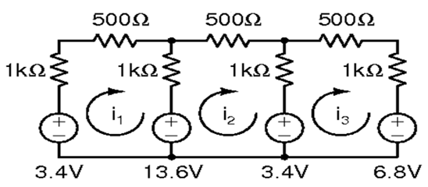  Fig.1 | [6M]
 | b) | State and explain Thevenin’s theorem with neat diagrams. | [4M]
12. | a) | An alternating voltage is expressed as V = 14.14 Sin 314t.  Determine:  i) RMS voltage  ii) Average Voltage  iii) Form factor and  iv) Peak factor. | [5M]
 | b) | If R=25Ω, L=20mH, C=120μF are connected in series across 220V,50Hz supply. Find  (i) Total current,  (ii) input power,  (iii) p.f. and  (iv) reactive power. | [5M]
13. | a) | Explain the working principle of operation of a D.C. generator. | [5M]
 | b) | A 240V DC shunt motor takes an input of 23kW. The armature and field resistances are 0.2Ω and 125Ω respectively. Neglecting stray and friction losses, determine the efficiency. | [5M]
14. | a) | Explain the equivalent circuit diagram of transformer from fundamentals? | [4M]
 | b) | For the given data, 4KVA, 200/400V, 50Hz. Find η, V₂ , I₁ , I_{FL} at 0.8 lag pf.  OC test(LV side) : 200V, 0.8A, 70W and  SC test(HV side) : 20V, 10A, 60W | [6M]
15. | a) | A balanced 3-ph delta connected load of 160kW takes a leading current of 100A with a line voltage of 11kV, 50Hz. Find the circuit constants of load per phase. | [6M]
 | b) | Explain rotor construction details of the three phase slip-ring induction motor. | [4M]
16. | a) | Explain the working principle of moving iron instrument with neat diagram. | [5M]
 | b) | Explain the different types of torques available in indicating instruments with neat sketches. | [5M]
17. | a) | Derive the expression for co-efficient of coupling in magnetic circuits? | [5M]
 | b) | Write short notes on losses in a DC machines. | [5M]
18. | a) | Derive the e.m.f. equation of the transformer with phasor diagrams? | [5M]
 | b) | How do you extend the range of given ammeter and voltmeter? | [5M]

-- 00 -- 00 –

